**KABARAK UNIVERSITY**



**SCHOOL OF SCIENCE, ENGINEERING AND TECHNOLOGY**

**INTE324: RESEARCH TEAM PROJECT**

**POLICE BOOKING SYSTEM**

**PRESENTED BY:**

**CHRIS NGATIA: INTE/MG/2341/09/19**

**IAN KIPROTICH: INTE/MG/2350/09/19**

**BARIMEN BOAZ KIPRONO: INTE/MG/2365/09/19**

**A TEAM PROJECT SUBMITTED TO THE DEPARTMENT OF COMPUTER SCIENCE AND INFORMATION TECHNOLOGY (UNDER THE SCHOOL OF SCIENCE, ENGINEERING AND TECHNOLOGY) IN PARTIAL FULFILMENT OF DEGREE IN INFORMATION TECHNOLOGY.**

**MARCH, 2022**

**Dedication**

We dedicate this project to our family precisely to our parents for the seemingly little yet huge impact they have made in our life in shaping us and making us believe in our strength rather than weaknesses and daring us to dream all through our course.

We would like to appreciate all our lecturers who instilled in us lifelong values and the desire for education. Finally, we would like to appreciate all of you who have contributed to our success and have not been mentioned above, remember that all your efforts are highly appreciated and you will never be forgotten for your stake in our life, God bless you all.

**Acknowledgment**

We would like to acknowledge God Almighty for the strength, sound mind, and provision during the period of study.

Special thanks to our supervisor Madam Mercy Gachoka for her immense support, guidance, and patience, and without her constructive criticism and advice this work would not have been complete. Surely your great counsel, skill, and experience could not have passed unnoticed.

**Statement of Originality**

We hereby declare without reasonable doubt that the work presented in this proposal is our own original work and independent work and it has not been presented before to the faculty of Science Engineering and Technology for the award of Bachelor’s Degree of Information Technology at Kabarak University or other institution. We have followed the guidelines provided by the University and close Supervision of Madam Mercy Gachoka.Whenever we have used materials from other sources, we have given due credit to them and given details in the references.

Submitted by:

CHRIS NGATIA INTE/MG/2341/09/19 Signature……………Date…………………

IAN KIPROTICH INTE/MG/2350/09/19 Signature……………Date…………………

BARIMEN KIPRONO INTE/MG/2365/09/19 Signature…………… Date…………………

Supervisor

Madam Mercy Gachoka Signature……………………... Date…………………

**Abstract**

This project explores the relevance of management systems to a contemporary society where computers have made normal operations and tasks easier, more efficient, and organized. Police Booking System is a planned system of collecting, storing, processing, and dissemination of data in the form of information needed to carry out various functions which come to simplify the tiresome manual way of reporting and writing the daily occurrences on papers.

There is a need for a system that can be used to store reported criminal activities in a centralized database which should replace the manual system that is currently being used in the police department. The manual system has a few challenges that include the ever-increasing paper load, difficulty in enforcing access control as well as cases of missing files and information.

Our objective regarding the project is to come up with an application that will be used to automate the manual management of Kenyan criminal records and hence the title “Police Booking System”.

The research methodology used in this project was System development lifecycle, using the waterfall method simply because the project was small and there are no uncertain requirements. At the end of each phase, a review takes place to determine if the project is on the right path and whether or not to continue or discard the project

The design was majorly aided by the dataflow context diagrams which are often used as a preliminary step to create an overview of the system. Use-case diagrams and activity diagrams also helped in coming up with the database class diagram which we used to develop the database.

Table of Contents

**CHAPTER 1** 10

**INTRODUCTION** 10

**1.1 Introduction** 10

**CHAPTER 2** 14

**LITERATURE REVIEW** 14

**2.0 Introduction** 14

**2.1 Some Related Works** 15

**CHAPTER 3** 17

**METHODOLOGY** 17

**3.1 Introduction to the chapter** 17

**3.2 System development methodology** 17

**3.2.1 System Planning** 18

**3.3 DESIGN DIAGRAMS** 19

**CONTEXT DIAGRAM** 19

**CHAPTER 4** 25

**SYSTEM IMPLEMENTATION AND DEPLOYMENT** 25

**4.1 Introduction** 25

**4.2. System Architecture** 25

**4.2.2 Register a new user** 25

**4.2.3 Ban user** 25

**System Design** 32

## 

**CHAPTER 1**

**INTRODUCTION**

**1.1 Introduction**

**Background of the study**

Protection of lives and property is ensured when individuals appreciate these rules of behavior and regulations. Our country must devise conduct and laws to govern the behavior of society’s members to maintain peace and harmony

The traditional and age-old intelligence system has failed to meet the demands of today's crime situation in Kenya. Manual methods do not give precise, dependable, and comprehensive data 24 hours a day, nor do they aid in trend prediction or decision-making. It also leads to poorer productivity and inefficient manpower usage. The proper application of information technology is the solution to this ever-increasing problem. Computer-generated records serve as an interface for integrating and retrieving large volumes of location-based data in the Crime Tracking Information System.

Police officers can use the police booking system to properly organize emergency responses, set mitigation priorities, analyze previous incidents, and forecast future events.

The goal of the project is to create a police system that will keep digital records of all police cases and crimes committed. The system is a desktop program that may be used by officers from around the department. This system can be used to handle records of various activities related to first information reports in the police departments. We will manage all such actions (such as crime booking registration, updating information, searching for specific reports of crimes) In such a desktop booking file system, which will save time and manpower. This method will provide a greater opportunity for the company to improve in terms of quality and openness.

**Statement of the Problem**

**1.2 Problem statement**

The Kenya Police Department, which serves as a case study, already has a system in place, but it is not automated. Paper and pen are used to keep track of crimes records. The archiving of these crimes’ records isn't particularly impressive.

Some case files are stacked, while others are maintained on shelves. Because of the state's moldy nature, crucial documents quickly become dusty, and some criminal records are severely destroyed by rats that eat on them due to a lack of suitable storage. In this situation, tracking down a known criminal, accessing a suspect's past criminal history, and knowing the status of some closed cases becomes extremely difficult, if not impossible.

These results in the following problems;

1. Increased in criminal activities due to delay in response time from the police department. The common Kenyan (Mwananchi) currently lacks platform to report criminal activities encountered on different parts of the country.

2. Missing files containing criminal reports. This result in criminal going unpunished when hearing a case in the court of law. Missing files means missing crime report collected at the crime scene.

3. Lack of effective coordination between the different national security organs.

Based on the above drawbacks the current system has been proposed.

**1.3 Objectives**

The project aims to computerize the Kenya Police's booking System. The project will accomplish the following objectives:

**Main Objective**

The main objective of this system can broadly be listed as follows:

- To keep record of the criminals and crime activities  
- To keep record of criminals’ details for future investigation  
- To reduce manual and redundant records keeping  
- Facilitate interaction and sharing of information among police departments, state/headquarters and other police agencies  
- Building security and monitoring control to ensure only authorized personnel have access to the criminal information

Other objectives

1. From the time the incident is reported to the police to the time the suspect appears in court for prosecution, the database system will gather detailed information about the criminal suspect.
2. The systems will include features that allow crime data to be cleaned, updated, and queried from the system.
3. Facilitate communication and information exchange between police departments, districts, state/headquarters, and other law enforcement agencies.
4. Building security and monitoring controls are in place to guarantee that only authorized individuals have access to crime data.

The central database system will be housed on a server at the police headquarters and will be linked to both the local police station and the Central Criminal Registry via a client-server system.

**1.4 Justification of project**

Should illustrate why the researcher is conducting the research proposal and whom it shall

Benefit.

The reason why we should implement a police booking system is to ensure that police get useful information on people with criminal records so that the police can enhance security in the area.

Different police stations will be able to communicate with each other through the system which will enable easy transfer of information that will help police in scenarios e.g. that a convict has escaped the data is sent to every precinct.

Also, the management of the information is sent can happen due to the creation of such a system. This will thus enhance security.

Helps users to store case reports of the police force, Complaint Details, FIR Details, etc.

**1.5 Scope of the study**

Generally, the idea of Police Booking System should be of national concern, since the Kenyan police sensitive information pertaining criminal’s records should be kept in a centralized and secure database. The system is meant to capture all the details required for a criminal reported, criminal activities, and retrieve them when required.

The users of the system will be police, police undercover agents, and administrator from the different security organs who has all the privileges to manipulate the data in the system. It should also target all the police stations and posts in all the 47 counties of the country and covering all the police officers who are approximated to be 80,000-100,000 police officers. It should also be scalable to accommodate around 10,000 private investigators in the country.

We are more focused on creating and implementing software-based criminal data tracking and dissemination through the distribution systems for use by Kenyan police to track and share criminal information in all/many stations.

**1.6 Limitation of the project**

1. Gathering data from police stations may be very difficult since they may be very suspicious of what you are asking them for, data.
2. Also due to time and financial constraints we were not able to get to go to all police stations.
3. Conversion of paperwork to electronic data may also be hectic.
4. Where to store the data that you need to use to distribute it to all station

**CHAPTER 2**

**LITERATURE REVIEW**

**2.0 Introduction**

Computer security is the field that tries to keep information confidential and with high level of integrity while at the same time make it available to individuals who access the data sensitive information. Part of this include; authentication and validation (making sure you are who you claim to be), encryption (making sure data gets where you want to go, without others being able to understand it) and physical security.

In the modern high-tech world, information is so crucial that every aspect of our lives is based on it. Values placed on information in the present generation cannot be underestimated. Almost all information is electronically stored and a large percentage of it is stored in a computer system.

According to the report by the national police service commission (Serianu, 2014) a number of the security lapses have been experienced during the period under review can be attributed to the lack of effective coordination between the different national security organs. Through interviews with various officers within the

National Police Service (NPS), the Commission established that there are serious lapses of coordination within the service. Lack of operational congruence between the different national security organs has affected information sharing and the carrying out of joint policing operations.

The Kenya Police Records Management System is a system that will provide for the storage, retrieval, Retention, manipulation, archiving, and viewing of information, records, documents, or files pertaining to law enforcement operations.

The system covers the entire life span of records development—from the initial record generation to Record completion. Moreover, the system allows single entry of data, while supporting multiple Reporting mechanisms. The records include: incident and accident reports, arrests, citations, warrants, Case management and field contacts. There is no existing record management in Kenya but research has been done Raptor Technology limited showing the need of having a record management system in the police sector. The most unique feature they came up with was the Volume, rate, and trends of crime indicators in their proposed system.

Each statistic meant to provide a different perspective of the crime experience. (Raptor, 2016)

The project is aimed to develop a crime file to maintain computerized records of all the incidents against crime. The system is a desktop application that can be accessed throughout the police department. This system can be used as an application for the crime file of the police department to manage the records of different activity related to the first information report. In the suck desktop crime file system, we will manage all such activities (like registration of the criminal, updating information, a search of particular viewing of the respective reports of crimes) that will save time, manpower. This system will provide a better perspective for the enhancement of the organization regarding quality and transparency.

In this research work, the web-based Police Booking System aims to use mobile devices in place of traditional GPS devices to facilitate the police to record the location of the committed crime. Despite the location-based service, the system offers the police to describe the detail and simultaneously attach the images or multimedia files. The online crime reporting system has been developed to override the problems prevailing in the practicing manual system. This software is supported to eliminate in some cases reducing the hardships faced by the existing system. ( Prakruthi Prakasha, et.al [1].2011)

**2.1 Some Related Works**

As essential apparatus in crime analysis, crime mapping and Geographical Information Systems (GIS) are being progressively more accepted by police agencies. Development in technology and the accessibility of geographic data sources make it feasible for police departments to use GIS and crime mapping. GIS and crime mapping can be utilized as devices to discover reasons contributing to crime, and hence let law enforcement agencies proactively take action against the crime problems before they become challenging. The purpose of this study is to conduct a literature review of Geographical Information System and Crime Mapping in Crime Analysis and to propose policy recommendations regarding to implementation of crime mapping and GIS.( Murat Dağlar, et.al [2].2010)

This feature is made available to public for interaction with police indirectly. This system registers the complaints from people through online and is helpful to the police department in identifying criminals. In this system any person can register their complaint online. The aim of this project is to develop an E-cops reporting and management system which is easily accessible to the public, police department and the administrative department. Generally, many crimes seen by the public will not reach to the police due to many reasons like fear, lack of time, ignorance. Due to this reason many cases are not even reported to the police station. Though some cases are registered they are not investigated properly due to lack of evidences and cooperation of the public. (Prof. V. V. Bhujade, et.al [3].2011)

**CHAPTER 3**

**METHODOLOGY**

# **3.1 Introduction to the chapter**

The project methodology used in the development of the system is the System Development Life Cycle (SDLC) specifically following the waterfall method. The SDLC is the process of understanding how information system can valid to the user needs, then designing the system, building it and delivering it to the potential users. This methodology is composed of some phases. The structured design methodology will be waterfall development.

# **3.2 System development methodology**

The Waterfall Model was first Process Model to be introduced. It is also referred to as a linear-sequential life cycle model. It is very simple to understand and use. In a waterfall model, each phase must be completed fully before the next phase can begin. This type of model is basically used for the project which is small and there are no uncertain requirements. At the end of each phase, a review takes place to determine if the project is on the

right path and whether or not to continue or discard the project. In this model the testing starts only after the development is complete

In the course of developing the system we chose to use the Waterfall Development Model as illustrated in the figure below,

Analysis

Planning

Coding and Design

Implementation

Testing

Deployment

# **3.2.1 System Planning**

In planning phase which was first step was to identify needs for police record managements system. This was first phase of the system and it entailed determining the necessary information that was required for the system to be fully operational as well as function in the expected manner. The requirements that we captured were subjected to thorough scrutiny to determine the level of essence of it as well as eliminate the unwanted requirements. We did this based on the fact that though the requirements might have been raised by the target users found through our research, they might not be realistic or might not be so much important.

# **3.2.2 System Analysis**

In this phase, we analysed and considered the current systems and investigated any problems associated with it. Other sources of information about system and the new requirements were also investigated at this time. The important information from the planning phase was highly used in this phase, and the valid information gathered was analysed for the design stage.

**3.2.3 System Design**

After the requirements, having already been captured and analysed, the design of the information flow was done to show the logical structure of the system. It is in this phase that the use case, dataflow diagrams and entity relationship diagrams were drawn to show flow of information and the activity diagrams were developed to show the connection that will exist between one party to another. Details are discussed in our next chapter 4.

**3.2.4 System Coding and Implementation**

After the design of the interfaces as well as the indication of the information flow through the Sequence diagrams and the flowcharts algorithms, the next step was to develop code abstracting the functionality of the system to realize the already fore-mentioned set objectives. The code was in relation to the information flow and therefore the flowcharts developed earlier were now applied here. The requirements documentation was referred throughout the rest of the system development process to ensure the developing project aligns with the needs and requirements or scope. A proper execution of the previous stages ensured an easier realization of this phase in the course of my development. Upon completion of the coding, the various components of the system were then integrated in to one system in order to function collectively as a single component. This is also covered in detail in chapter 4

**3.2.5 System Testing**

Last phase is system testing done when development is complete and the system is ready for deployment. The testing phase come next to determine if the earlier intended objective to have been realized by then. Testing was done based on whether completeness will have been realized or functional testing that determined whether the software is doing what it is expected correctly and in the right way. User testing was then carried out by a group of Informatics students to ascertain that the users will be contented with

what will have been achieved then and this has been discussed in detail in chapter 5..

**Reason for using Waterfall Model**

* It is easy to understand and follow as it provides a clear guideline.
* Clearly define stages and processes and results are well documented.
* Simple and easy to understand and use.
* Works well for smaller projects where requirement are very well understood.
* In this model phases are processed and completed one at a time. Phases do not overlap.

**3.3 DESIGN DIAGRAMS**

**CONTEXT DIAGRAM**

**Context Dataflow Diagram**

A data flow diagram is a graphical representation of the flow of data through an information system, modelling its process aspects. A DFD is often used as a preliminary step to create an overview of the system, which can later be elaborated. DFDs can also be used for the visualization of data processing.

A DFD shows what kind of information will be input to and output from the system, where the data will come from and go to, and where the data will be stored. It does not show information about the timing of process or information about whether processes will operate in sequence or in parallel.

The figure below shows the flow of information in the Police Booking system which entail three users of the system and these are the administrator, the police and the client.

Context Dataflow Diagram

Police

Booking

System

Crime

Management

Charge Sheet

Police Details

Crime Details

Court Management

Complain Management

LEVEL 1 DIAGRAM

AUTOMATIC

POLICE

BOOKING

SYSTEM

Generate Crime

Report

Crime Management

Complain

Management

Generate Complain

Report

Generate Charge

Sheet Report

Charge Sheet

Court Management

Generate Criminal

Report

Generate Court

Report

Criminal

Management

**4.3 Data Flow Diagram**

**4.3.1 DATA FLOW DIAGRAM**

A data flow diagram is a graphical representation of flow data in an information system. It is capable of depicting incoming data flow, outgoing data flow, and stored data. The DFD does not mention anything about how data flows through the system.

There is a prominent difference between DFD and flowchart, the flowchart depicts the flow of control in program modules. DFDs depict the flow of data in the system at various levels. DFD does not contain any control or branch elements

**4.3.2 TYPES OF DFD**

Data flow diagrams are either logical or physical.

- Logical DFD – this type of DFD concentrates on the system process and flow of data in the system.  
- Physical DFD – this type of DFD shows how data flow is implemented in the system. It is more specific and closer to the implementation.

**4.3.3 DFD COMPONENTS**

DFD can represent source, destination, storage, and flow of data using the following set of components-

- **Entities –** entities are the source and destination of information data. Entities are represented by rectangular with their respective names.  
- **Process –** activities, and actions taken on the data are represented by a circle or round-edged rectangles.  
- **Data storage –** there are two variants of data storage- it can either be represented as a rectangle with the absence of both smaller sides or as an open-sided rectangle with only one side missing.  
- **Data flow –** the movement of data is shown by pointed arrows. Data movement is shown the base of the arrow as its source towards the head of the arrow as a destination

**2nd LEVEL DFD – POLICE BOOKING SYSTEM**

Manage Department Details

Manage Crime Details

Check roles of the Access

Manage

Modules

Check

Credentials

Login to the System

Send

Email to the user

user

Forgot

Password

Manage User Permissions

Manage Roles of Users

Manage System Admin

Manage Daily Reports

Manage Complain Details

Manage Police Details

Manage Criminals Details

Manage Case Details

Admin

Use Case Diagram

**Admin**

Login

Add Police

Category

View Case

Add Case

Add police

Formulation

Create User

Add Criminal

**CHAPTER 4**

**SYSTEM IMPLEMENTATION AND DEPLOYMENT**

# **4.1 Introduction**

Upon the completion of the Police Booking System, there are a number of things that will be expected of it not only by the prospected users but also for the administrator of the system. These will therefore form the requirements and will be broadly classified in to the functional requirements and the Non-functional requirements.

# **4.2. System Architecture**

**4.2.1 User Login**

This feature is used for the 2 types of users (police and Client) to login in to the system. Where client in this case can be a lawyer, undercover police agents or private investigators. They are required to key in the Email Address and the password before they are granted permission to enter the system. The username and the password will be verified and the invalid username and password are not allowed to enter the system. All users are registered by the administrator. The system must only allow the user with valid username and password to enter the system.

# **4.2.2 Register a new user**

This feature is used by the administrator to register new system users to ensure that all details are available and valid. System ensures that the information supplied by the user (Admin) is of the correct form through the input type of the registration forms.

# **4.2.3 Ban user**

This feature allows the administrator to user from using the system. This functionality is only meant for system administrator and other system user can access this functionality. System searches the record from the database and displays the entire details to the user. System must be able to show out the correct information about particular user.

**4.2.4 Add/edit/delete police Category and police formulation**

This feature will allow the admin user to add, edit and delete the records of other police category and police formulation in the database. Admin selects the particular police category or police formulation from the records to view the details to be edited. The System responds by displaying the entire details of that particular category or formulation. The Admin then edits the records as required and updates. The admin is also able to delete police

category and police formulation from the police category and police formulation system database tables. System must be able to fetch the correct details from the database and display them to the user. System must inform the system admin of the update success once the record has successfully updated.

**4.2.5 Add Station**

This feature allows the administrator to add stations in the system. Once the police station details have been added to the system database, the admin is also able to edit the details and delete the delete the details from the system database. System searches the record from the database and displays the entire details to the system user. System must be able to show out the correct information about particular police station.

**4.2.6 Add criminal**

This feature allows all the system users to add criminal’s records into the system. Once criminal’s records have been added to the system, the system admin has the privilege to edit, upload the criminal’s picture and deleting the criminal’s information in the system.

**4.2.7 Report Cases**

This feature is used by all system users (admin, police, and client). This feature allows the system users to feed reported case incidences into the system. Once the case information has been stored in the system’s database, the system admin has the privilege of retrieving the case information, edit and can also delete the case information from the system database.

* 1. **Non-functional Requirements**

**4.2.1 Reliability requirements**

The system must perform accurately towards the administrator request. For example, when the administrator saves the edited details of the user, after he reviews the details later, they must be changed according to the latest details that was updated. Moreover, the agent is not allowed to view the details that the administrator has. Besides that, the login form will have validity check to ensure that only the authorized users gain access to the system.

**4.2.2 Usability requirements**

This system must be designed with user-friendly and easy to use by all the users so that they can perform their tasks easily.

**4.2.3 Implementation requirements**

In implementing the system, it uses pup as the main programming language. This forms the front-end and the middleware. At the back-end, MySQL will be synchronized and be used to maintain the information in the database. This is formed by the databases and other data stores.

**4.2.4 Security Requirements**

This system authentication protocol and access control must be highly secured in the login part. Where username identities and passwords are encrypted and hashed using MD5 function. This is because some privileges are only meant for the System Administrator only. Meaning that if the security is compromised, the whole system is compromised. Our Database is also hashed using both MD5 and SHA-1 encryption algorithms functions.

**4.3 Front end Development**

<?php

include('../session.php');

include('header.php');

include('dbconnect2.php');

 ?>

<div class="container-fluid">

      <?php include('menubar.php')?>

    <?php // include('menubar1.php');

    $staffid=$_GET['id'];

    ?>

<div class="container-fluid">

    <div class="col-md-2"></div>

    <div class="col-md-8">

        <ul class="list-group" id="myinfo" >

            <li class="list-group-item" id="mylist"></li>

        </ul>

            <div class="panel panel-success">

                        <div class="panel-heading">

                            <h3 class="panel-title">Enter Login Details</h3>

                        </div>

            <div class="panel-body">

                <div class="container-fluid">

                    <form class="form-horizontal" id="addstaff"  role="form">

                        <div class="form-row">

                        <div class="col-md-6">

                            <div class="form-group">

                                <label for="">Staff ID:</label>

                                <input type="text" readonly="" value="<?php echo $staffid?>" name="staffid" class="form-control" id="staffid" placeholder="Enter StaffID" >

                            </div>

                        </div>

                </div>

                        <div class="form-row">

                            <div class="col-md-6">

                                <div class="form-group">

                                 <label for="">Password:</label>

                                    <input type="password" readonly="" name="pwd" value="1234" class="form-control" id="pname"

                                autofocus=""  >

                                </div>

                            </div>

                            <div class="col-md-6">

                            <div class="form-group">

                                <label for="">Select Status:</label>

                                        <select class="form-control" name="status" id ="sdcrime">

                                        <option selected="selected" value="">Select</option>

                                            <option value="CID"> Admin </option>

                                            <option value="Admin"> CID </option>

                                            <option value="NCO"> NCO</option>

                                         </select>

                                </div>

                            </div>

                        </div>

                      </div>

                      <div class="form-group">

                      <button  type="submit" name="save_case" class="btn btn-success form-control">Save and Continue

                      <span class="glyphicon glyphicon-arrow-right" aria-hidden="true"></span>

                      </button>

                    </div>

                    </form>

                </div>

            </div>

        </div>

    </div>

    <div class="col-md-2"></div>

</div>

<?php include('scripts.php'); ?>

<script type="text/javascript">

    $(document).on('submit', '#addstaff', function(event) {

        event.preventDefault();

        // This removes the error messages from the page

         $(".list-group-item").remove();

        var formData = $(this).serialize();

            $.ajax({

                    url: 'saveuserlogin.php',

                    type: 'post',

                    data: formData,

                    dataType: 'JSON',

                    success: function(response){

                        if(response.error){

                            console.log(response.error);

                    }

                        else{

                            Swal.fire({

                              position: 'top-end',

                              icon: 'success',

                              title: 'Staff Saved',

                              showConfirmButton: false,

                              timer: 3000

                            setTimeout( function(){

                                window.location='addstaff.php';

                            }, 900);

</script>

**4.4 Flow Chart**

Admin

No

Yes

Admin

start

login

Check

Add suspect

index

Database

Del

Record

Edit

Suspect

Exit

Database

System design is the process of defining the architecture, components, modules, interface, and data for a system to satisfy the specified requirements. System design could be seen as the application of system theory to product development.

This system suggests an investigation system that feature unlimited registration of police suspect which are murder, robbery, cultist, scam, suspect, trespassers, defaulters, criminals and other unlisted suspect can be enlisted into any of this arrays, and the choice of the core programming and database language used in the development of this project is PHP Hypertext processor and MYSQL database, MySQL holds the tables that contains all the information and functioning of this system and these tables are: Admin tables which holds information about the administrator, suspect tables which holds the information about all the suspect in the database, the testing tables holds several crime category that will be available in the system, the student table contains all the information about voters and users to develop this system which are PHP, JavaScript, CSS and HTML, both JavaScript and have been basically used for styling and positioning of web component and HTML is known as Hypertext markup language which is the structure that builds any web page. This system contains the login page for both the administrator and the staff in charge of the police station, the system also has a menu for adding staff, recording new cases, and viewing cases.

**System Design**

The phase of the design process is given below:

- Architectural design: the design of system architecture which describes the structure behavior.  
- Logical design: it’s an abstract representation of the data flows, inputs, and outputs of the system, the requirements about the system are described.

- Input requirements  
- Output requirements  
- Storage requirements  
- Processing requirements  
- System control and backup or recovery

Another way the physical portion of system design can generally be broken down into three sub-tasks:

- User interface design.  
- Data design.  
- Process design

**4.5 User Interface Modules(Screenshot)**

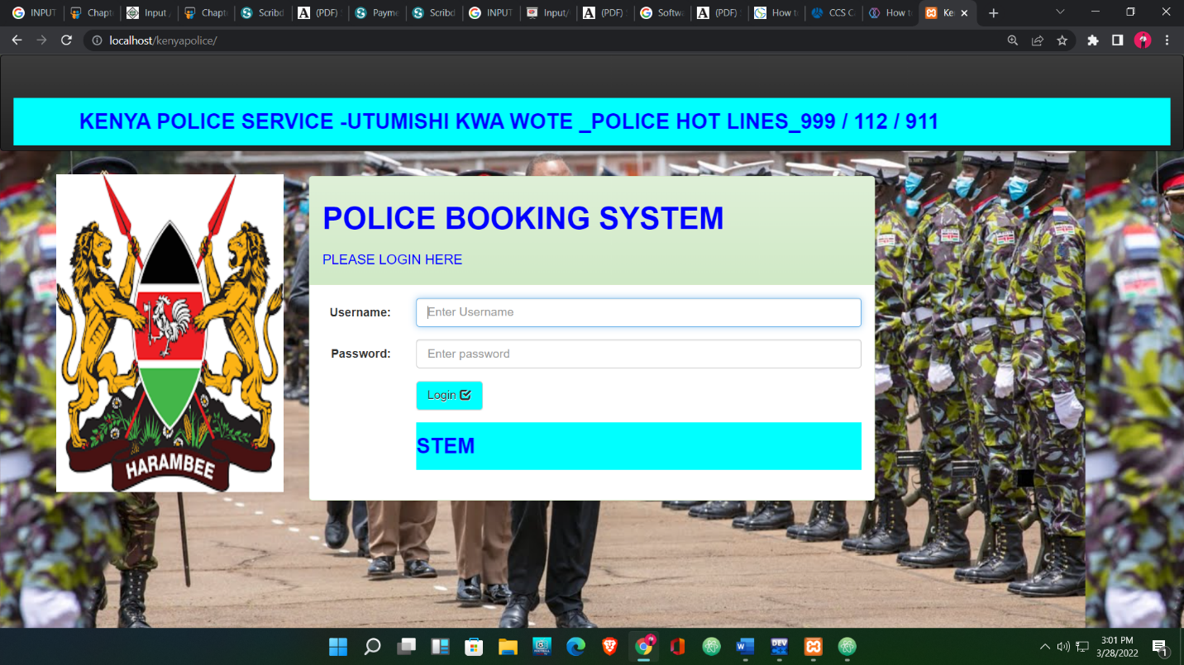ADMINISTRATIVE AND STAFF LOGIN PAGE

**4.6 Back end Development**

**4.1.1 DATABASE DESIGN**

The main function of a DBMS is to provide efficient and reliable methods of data retrieval to many users. The community of users of a DBMS includes a variety of individuals and organizational entities. These users are classified based on their roles and interest in accessing and managing the databases. The model of the database employed in this project is the entity-relationship (E/R) model. The E/R model uses the notions of entity, relationship, and attitude. These notions are quite intuitive. Informally, entities are objects that need to be represented in the database; relationships reflect interactions between entities; attributes are properties of entities and relationships. MySQL database was used throughout this study. This system made use of two (2) tables as listed below. Suspect table: This table holds all information about suspects in the police investigation system

SUSPECT DATABASE

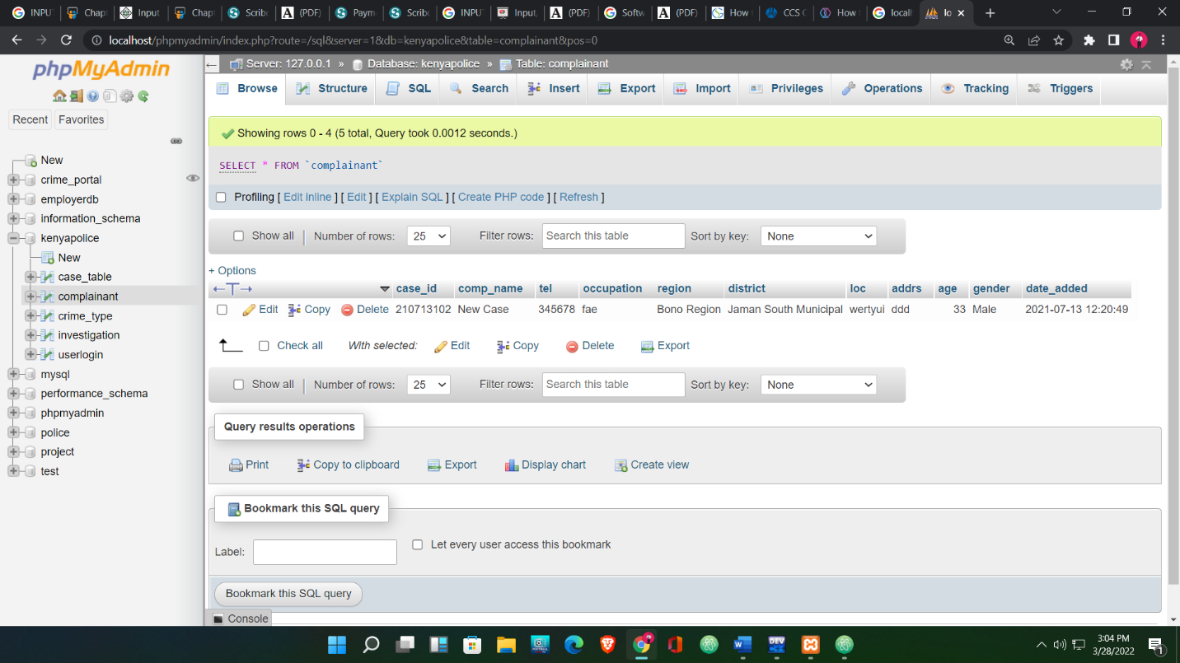

ADMIN LOGIN DATABASE

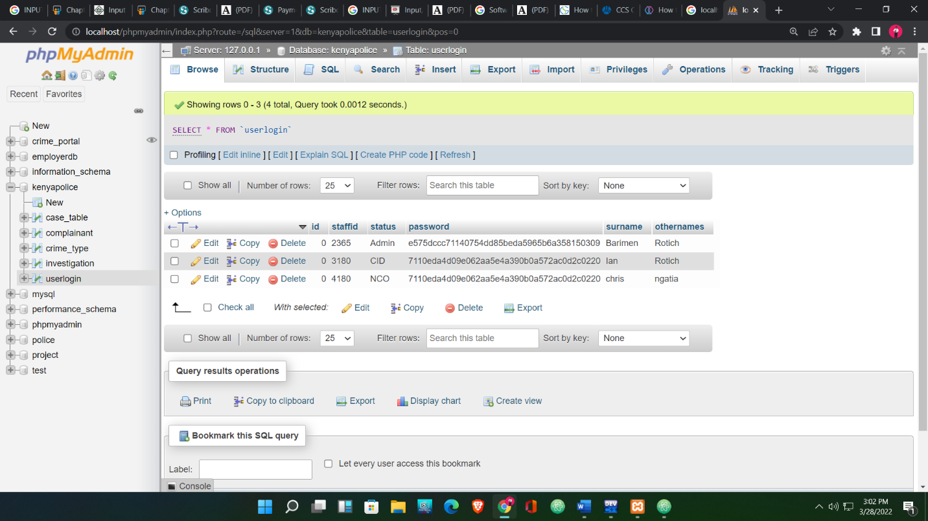

LOGIN PAGE

This page like all pages is prevented from direct URL access by ensuring that it can be allowed accessed login by an authenticated user. This page queries out the entire category in the position table in the database, new arrest only features suspect set in the database. The newest arrest page directs new suspects to the newest arrest array in the database



**Advantages of a database management system**

**Data Integrity**

Data integrity means that the data is accurate and consistent in the database. Data Integrity is very important as there are multiple databases in a DBMS. All of these databases contain data that is visible to multiple users. So, it is necessary to ensure that the data is correct and consistent in all the databases and for all the users.

**Data Security**

Data Security is a vital concept in a database. Only authorized users should be allowed to access the database and their identity should be authenticated using a username and password. Unauthorized users should not be allowed to access the database under any circumstances as it violates the integrity constraints.

**Privacy**

The privacy rule in a database means only authorized users can access a database according to its privacy constraints. There are levels of database access and a user can only view the data he is allowed to. For example - On social networking sites, access constraints are different for different accounts a user may want to access.

**Backup and Recovery**

Database Management System automatically takes care of backup and recovery. The users don't need to backup data periodically because this is taken care of by the DBMS. Moreover, it also restores the database after a crash or system failure to its previous condition.

**Data Consistency**

Data consistency is ensured in a database because there is no data redundancy. All data appears consistently across the database and the data is the same for all the users viewing the database. Moreover, any changes made to the database are immediately reflected all the users and there is no data inconsistency.

**INPUT AND OUTPUT DESIGN**

**CODING**

This step is also known as the programming phase. The implementation of software design starts in terms of writing program code in a suitable programming language and developing error-free executable programs efficiently

In the SDLC model, the design and coding of the program involved only 10% of the project’s commitment, here we compose the coding using a well-understood programming language like PHP, HTML, CSS3, BOOTSTRAP, JAVASCRIPT, JQUERY, and MYSQL

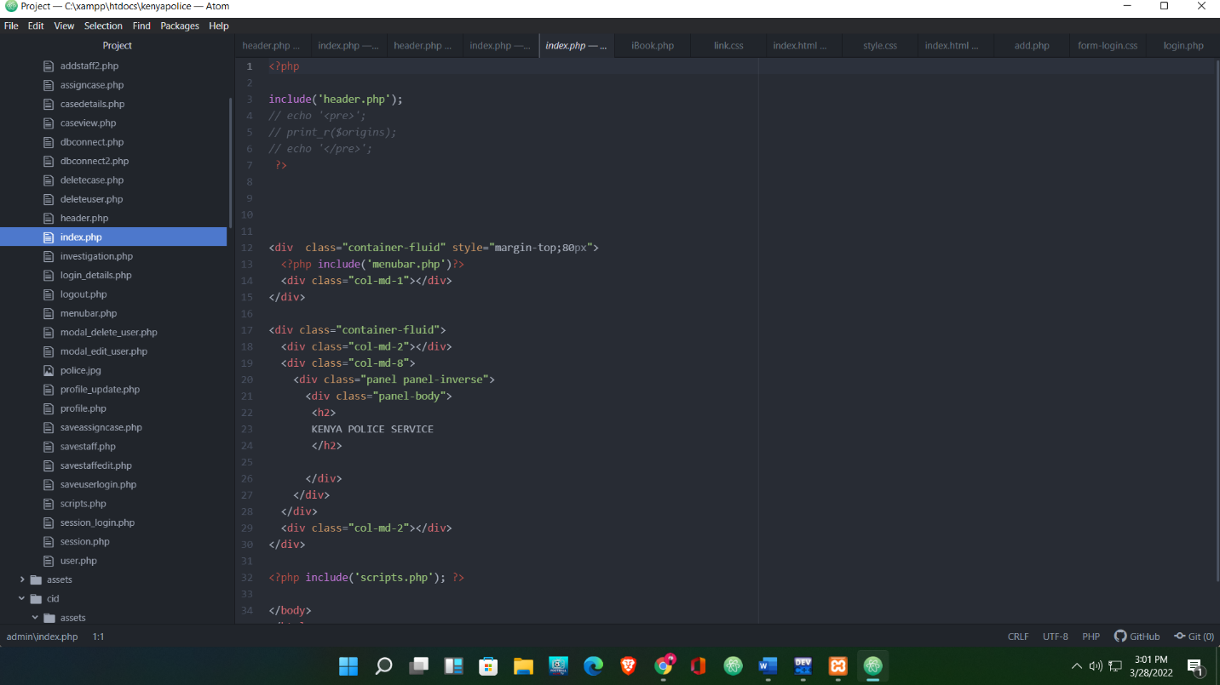

**SYSTEM REQUIREMENTS**

**SYSTEM IMPLEMENTATION TECHNOLOGIES**

The computer-based police investigation system using a biometric approach is developed as online information and eliminates the inadequacies in the security of records within the police command.

**Tools used in the implementation are listed below**:

**Php** – (Personal Home Page_ is now known as a hypertext processor. A dynamic server-side scripting language. PHP code is interpreted (not complied by a server with a PHP processor module, which generates the resulting web page. PHP commands can be embedded directly into an HTML source document rather than calling an external file to process data. It has also been evolved to include a command-line interface capability and used in standalone graphical applications.

**Java Script** – Dynamic client-side scripting language that responds to users’ events. JavaScript is very loosely based on Java, an object-oriented program language popularized for use on the Web by way of embedded applets. Although JavaScript has a similar syntax and programming methodology, it is not a “light” version of Java. Instead, JavaScript is its dynamic language, finding its home in web browsers around the world and enabling enhanced interaction on web site and web applications alike...

**HTML** – (Hypertext Markup Language is the main markup language) for layout and displaying information that can be displayed on the web. HTML is written in the form of HTML elements consisting of tags enclosed in angle brackets (like <html>), within the web page content. CSS – (Cascading Style Sheets) for describing looks and formatting documents. CSS is designed primarily to enable the separation of documents content from document presentation, including elements such as the layout, color, and fonts. Web browser – (commonly referred to as a browser) for retrieving and presenting information resources on the World Wide Web.

Xampp Server – Testing is done through Xampp sever. Windows Operating System - This system is developed and deployed on a Windows operating system – windows 7 ultimate precisely.

**Software Requirement Specification**

SRS is a document created by a system analyst after the requirement is collected by various stakeholders. SRS defines how the intended software will interact with hardware, external interface, speed of operation, the response time of the system, portability of software across various platforms, maintainability, speed of recovery after crashing, security, quality, limitations, etc. the requirements received from the client are written in natural language

**SRS features:**

* User requirements are expressed in natural language.
* Technical requirements are expressed in a structured language, which is used inside the organization.
* Design description should be written in Pseudocode.
* Format of forms and GUI screen prints.
* Conditional and mathematical notations for DFDs etc.
* Software Requirement Validation

After requirement specifications are developed, the requirement mentioned in this document is validated. The user might ask for illegal, impractical solutions or expected may interpret the requirements correctly. This results in a huge increase in cost if not nipped in the bud **Requirements can be checked against the following conditions**

* If they can be practically implemented
* If they are valid and as per functionality and domain of software
* If there are any ambiguous
* If they are complete
* If they can be demonstrated

**Software Requirement for Development**

**Requirement for software**

1. PHP
2. HTML
3. CSS
4. JavaScript
5. BOOTSRAP

**Hardware Requirements for Use**

1. Keyboard
2. Mouse
3. Screen solution of at least 1024*768 required for proper and complete viewing of the screen
4. RAM 1GB
5. Hard Disk 250 GB

**Software Requirements for use**

1. Operating system- Desktop and laptop-based OS
2. Server XAMPP Control v3.3.2
3. Application software PHP, MYSQL, JavaScript, Web browser like chrome

**Deployment of system**

Ones the system has undergone testing and passed all the validations and verifications, then the system would be termed to be acceptable and therefore it will be handed over to the owners for maintenance and operation as well

**GANTT CHART**

Gantt chart was devised by Henry Gantt (1917). It represents the project schedule concerning periods. It is a horizontal bar chart with bars representing activities and time scheduled for the project activities

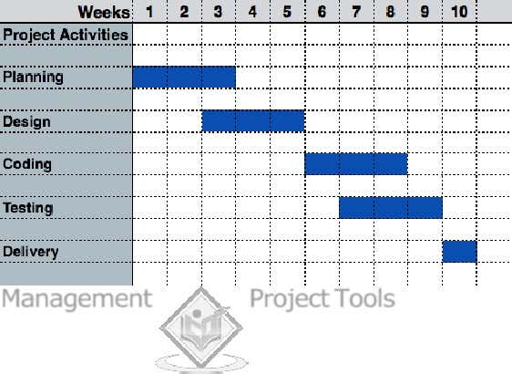

**Conclusion**

The "Police Booking System " will be extremely beneficial to the police department. This application has been discovered to be effective and efficient. The advantages of this software are its simplicity and friendliness. The application has been designed to be as user-friendly as possible, so that anyone with access to the system via login and password can run it. The software is equipped with a variety of features, including a criminal search option for future investigations, criminal and offense registration, and so on. During the analysis and design phases, all requirements are fully addressed, culminating in the creation of good software. This project takes care of all the intricacies without putting the project at risk.